Ex 9 :
ListofPlayers.js
import React from 'react';

const ListofPlayers = () => {
const players = [
{ name: 'Rohit', score: 85 },
{ name: 'Gill', score: 45 },
{ name: 'Kohli', score: 95 },
{ name: 'Rahul', score: 30 },
{ name: 'Iyer', score: 77 },
{ name: 'Pandya', score: 60 },
{ name: 'Jadeja', score: 35 },
{ name: 'Ashwin', score: 68 },
{ name: 'Bumrah', score: 90 },
{ name: 'Shami', score: 40 },
{ name: 'Kuldeep', score: 50 }
];

const below70 = players.filter(player => player.score < 70); // Arrow function

return (
<div>
<h2>All Players</h2>
{players.map((player, index) => (
<p key={index}>{player.name} - {player.score}</p>
))}

<h3>Players with Score Below 70</h3>
{below70.map((player, index) => (
<p key={index}>{player.name} - {player.score}</p>
))}
</div>
);
};

export default ListofPlayers;
IndianPlayers.js
import React from 'react';

const IndianPlayers = () => {
const teamPlayers = ["Player1", "Player2", "Player3", "Player4", "Player5", "Player6"];

// Destructuring the array
const [odd1, even1, odd2, even2, odd3, even3] = teamPlayers;

const T20players = ['Rohit', 'Kohli', 'Bumrah'];
const RanjiPlayers = ['Jaiswal', 'Sarfaraz', 'Unadkat'];

// Merging using spread operator
const allPlayers = [...T20players, ...RanjiPlayers];

return (
<div>
<h2>Odd Team Players</h2>
<ul>
<li>{odd1}</li>
<li>{odd2}</li>
<li>{odd3}</li>
</ul>

<h2>Even Team Players</h2>
<ul>
<li>{even1}</li>
<li>{even2}</li>
<li>{even3}</li>
</ul>

<h2>Merged T20 + Ranji Players</h2>
<ul>
{allPlayers.map((player, index) => <li key={index}>{player}</li>)}
</ul>
</div>
);
};

export default IndianPlayers;
App.js
import React from 'react';
import './App.css';
import ListofPlayers from './components/ListofPlayers';
import IndianPlayers from './components/IndianPlayers';

function App() {
const flag = false;
// Set to false to show IndianPlayers component instead

return (
<div className="App">
<h1>🏏 Cricket App</h1>
{flag ? <ListofPlayers /> : <IndianPlayers />}
</div>
);
}

export default App;
App.js
import React from 'react';
import './App.css';
import ListofPlayers from './components/ListofPlayers';
import IndianPlayers from './components/IndianPlayers';

function App() {
const flag = true;
// Set to false to show IndianPlayers component instead

return (
<div className="App">
<h1>🏏 Cricket App</h1>
{flag ? <ListofPlayers /> : <IndianPlayers />}
</div>
);
}

export default App;

Output :
Flag = true
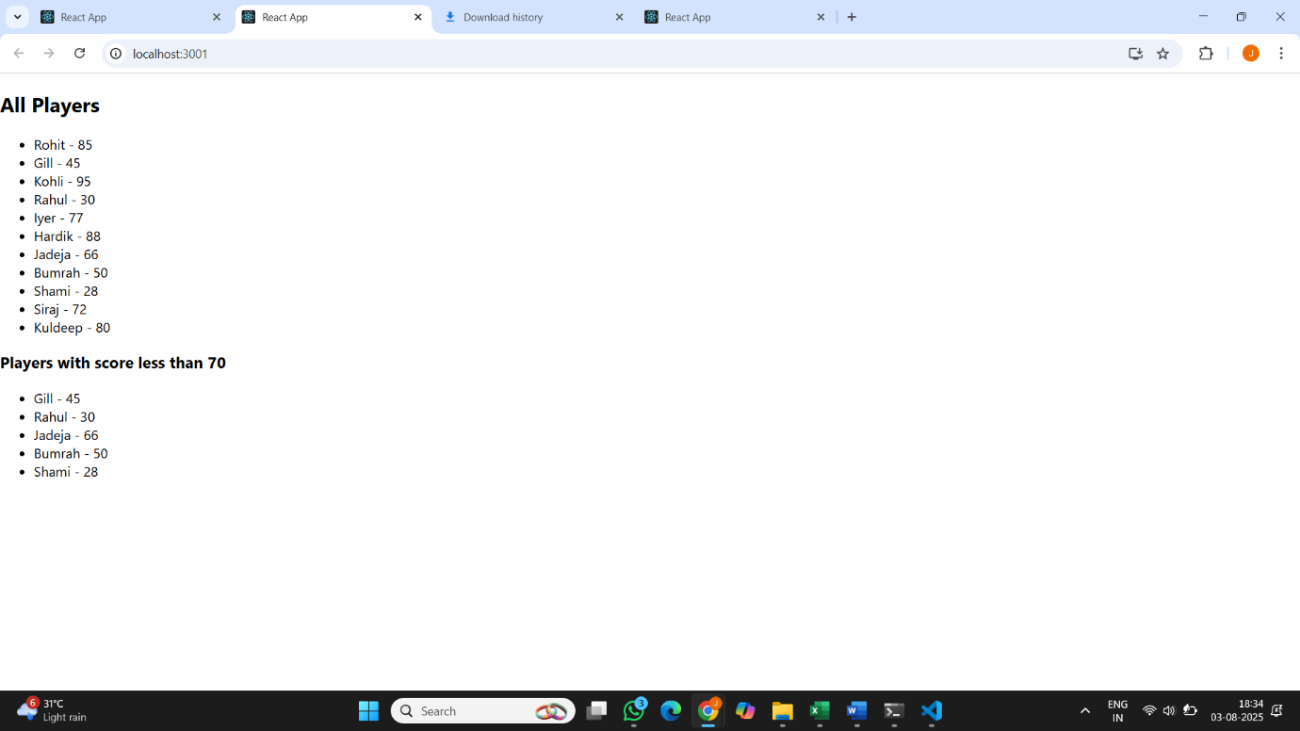
Flag = false
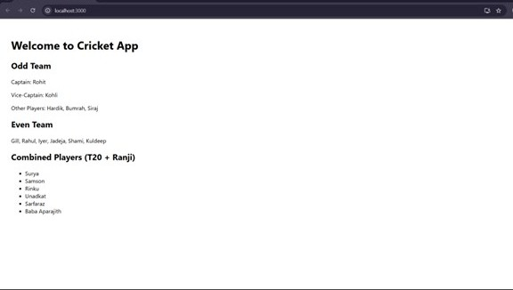

Ex 10
App.js
import React from 'react';

const App = () => {
const title = <h1 style={{ textAlign: 'center', margin: '20px' }}>Office Space Rental App</h1>;

const officeImage = "https://images.unsplash.com/photo-1581375271042-4aa5413cde7b";

const officeDetails = {
name: "Skyline Workspace",
rent: 58000,
address: "123 MG Road, Bengaluru"
};

const officeList = [
{ id: 1, name: "Urban Desk", rent: 62000, address: "Indiranagar, Bengaluru" },
{ id: 2, name: "TechHub", rent: 55000, address: "HSR Layout, Bengaluru" },
{ id: 3, name: "EcoSpace", rent: 72000, address: "Whitefield, Bengaluru" },
{ id: 4, name: "StartZone", rent: 48000, address: "Koramangala, Bengaluru" }
];

const getRentStyle = (rent) => {
return {
color: rent > 60000 ? "green" : "red",
fontWeight: "bold"
};
};

return (
<div style={{ padding: "30px", fontFamily: "Arial" }}>
{title}
<div style={{ textAlign: 'center' }}>
<img
src={officeImage}
alt="Office"
style={{ width: "80%", height: "300px", objectFit: "cover", borderRadius: "10px" }}
/>
</div>
<h2>Featured Office</h2>
<p><strong>Name:</strong> {officeDetails.name}</p>
<p><strong>Address:</strong> {officeDetails.address}</p>
<p><strong>Rent:</strong> <span style={getRentStyle(officeDetails.rent)}>{officeDetails.rent}</span></p>

<h2>Other Available Spaces</h2>
{officeList.map((office) => (
<div key={office.id} style={{ borderBottom: "1px solid #ccc", marginBottom: "10px" }}>
<p><strong>Name:</strong> {office.name}</p>
<p><strong>Address:</strong> {office.address}</p>
<p>
<strong>Rent:</strong>{' '}
<span style={getRentStyle(office.rent)}>{office.rent}</span>
</p>
</div>
))}
</div>
);
};

export default App;

Output :
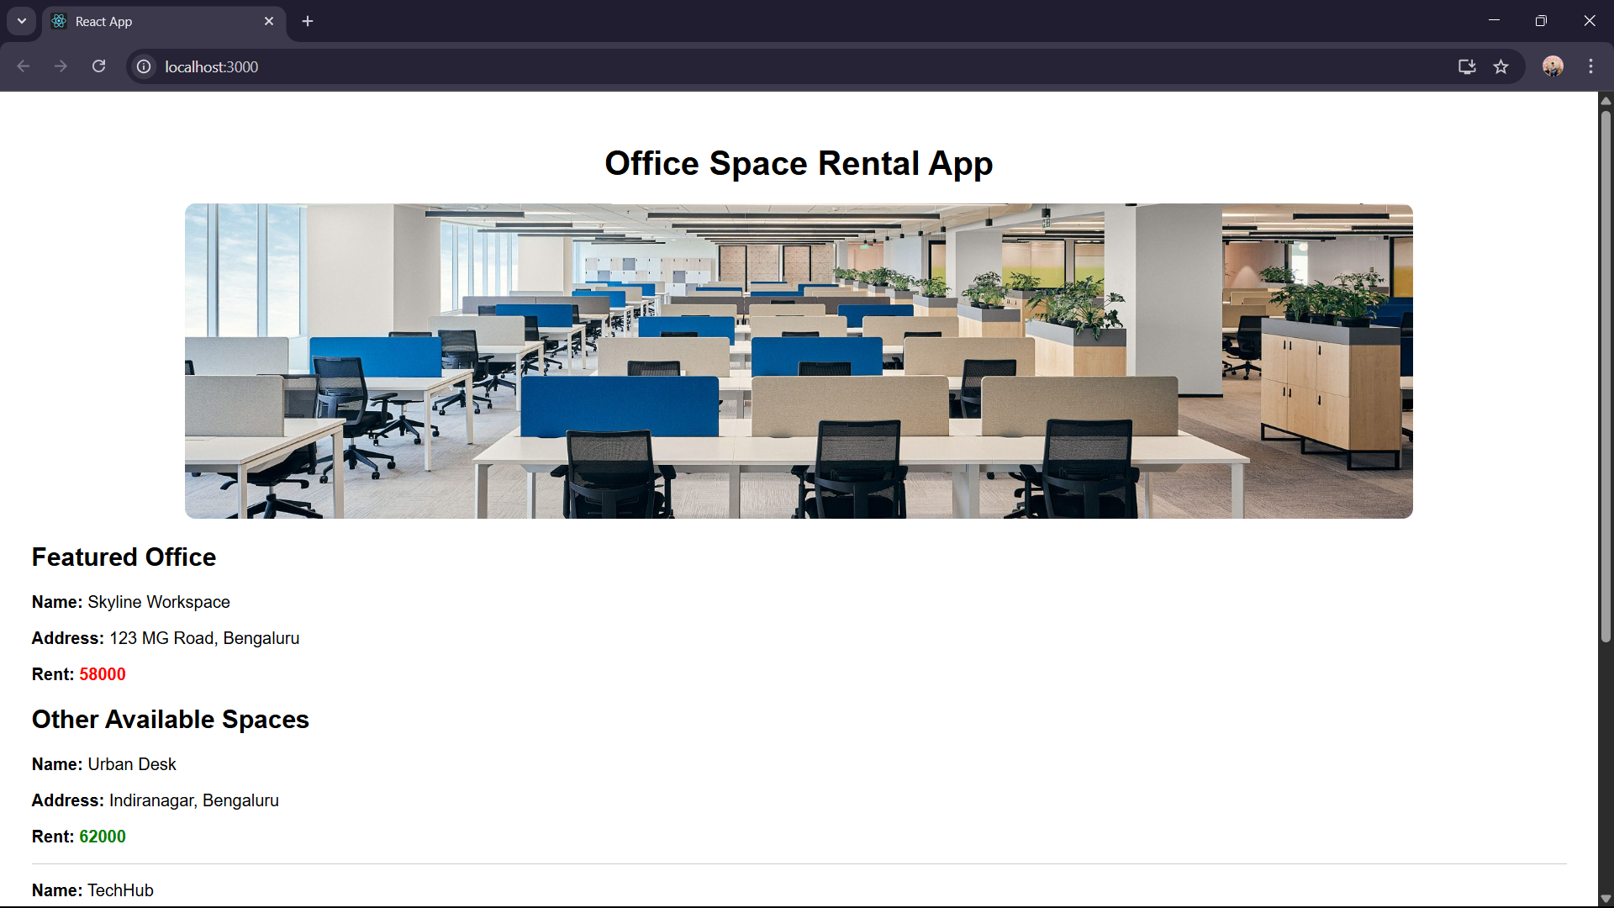

Ex 11
App.js
import React, { useState } from 'react';
import CurrencyConvertor from './CurrencyConvertor';

const App = () => {
const [count, setCount] = useState(0);

const increment = () => {
setCount(prev => prev + 1);
sayHello();
};

const decrement = () => {
setCount(prev => prev - 1);
};

const sayHello = () => {
console.log("Hello Abishek! Keep clicking!");
};

const sayWelcome = (msg) => {
alert(msg);
};

const handleClick = (event) => {
alert("I was clicked");
console.log("Synthetic Event:", event);
};

return (
<div style={{ padding: "40px", fontFamily: "Arial" }}>
<h1>React Event Examples</h1>

<h2>Counter: {count}</h2>
<button onClick={increment}>Increment</button>
<button onClick={decrement} style={{ marginLeft: "10px" }}>Decrement</button>

<div style={{ marginTop: "20px" }}>
<button onClick={() => sayWelcome("Welcome Abishek!")}>Say Welcome</button>
</div>

<div style={{ marginTop: "20px" }}>
<button onClick={handleClick}>Synthetic Event OnPress</button>
</div>

<hr style={{ margin: "30px 0" }} />
<CurrencyConvertor />
</div>
);
};

export default App;
CurrencyConvertor.js
import React, { useState } from 'react';

const CurrencyConvertor = () => {
const [rupees, setRupees] = useState('');
const [euros, setEuros] = useState(null);

const handleSubmit = (e) => {
e.preventDefault();
const conversionRate = 0.011; // Roughly 1 INR = 0.011 EUR
const converted = (parseFloat(rupees) * conversionRate).toFixed(2);
setEuros(converted);
};

return (
<div>
<h2>Currency Convertor</h2>
<form onSubmit={handleSubmit}>
<input
type="number"
value={rupees}
onChange={(e) => setRupees(e.target.value)}
placeholder="Enter amount in ₹"
/>
<button type="submit" style={{ marginLeft: "10px" }}>Convert</button>
</form>

{euros !== null && (
<p style={{ marginTop: "15px" }}>
{rupees} INR = <strong>{euros} EUR</strong>
</p>
)}
</div>
);
};

export default CurrencyConvertor;

Output :
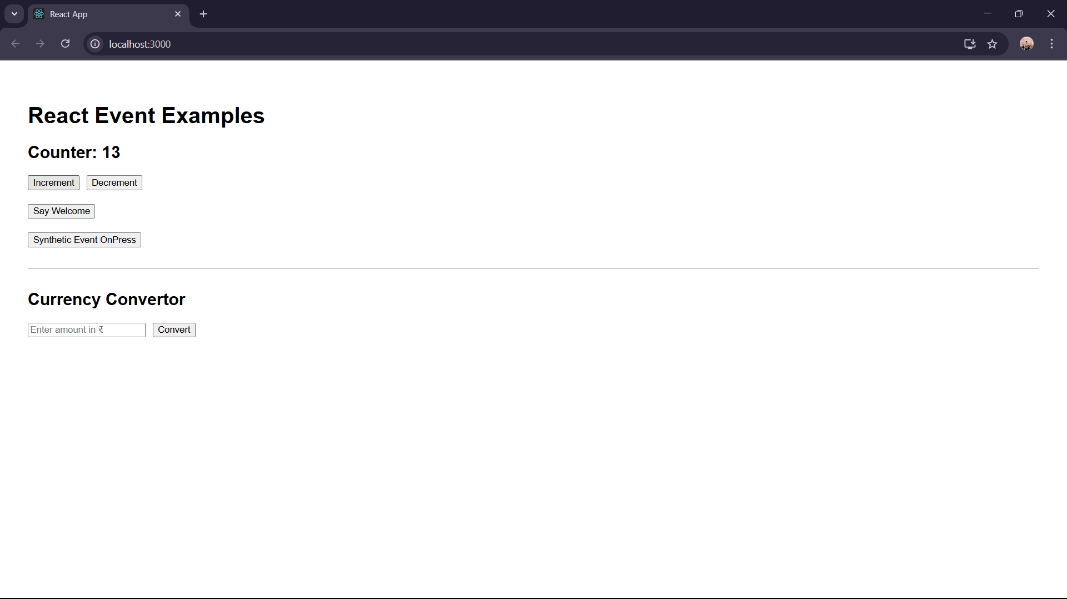

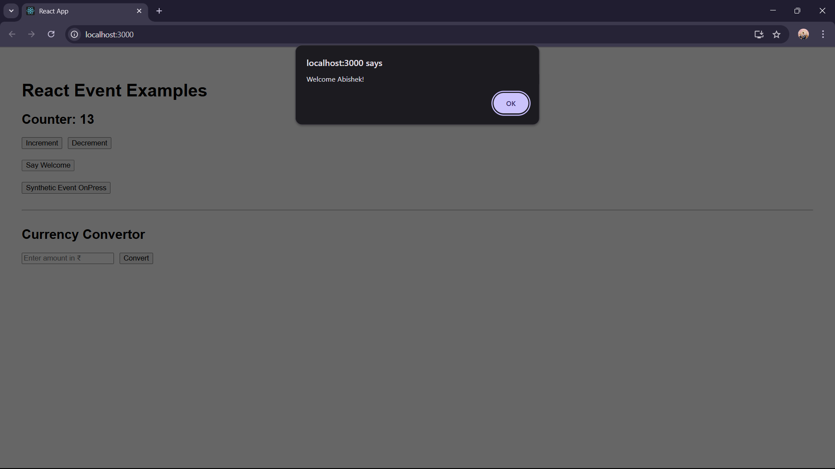
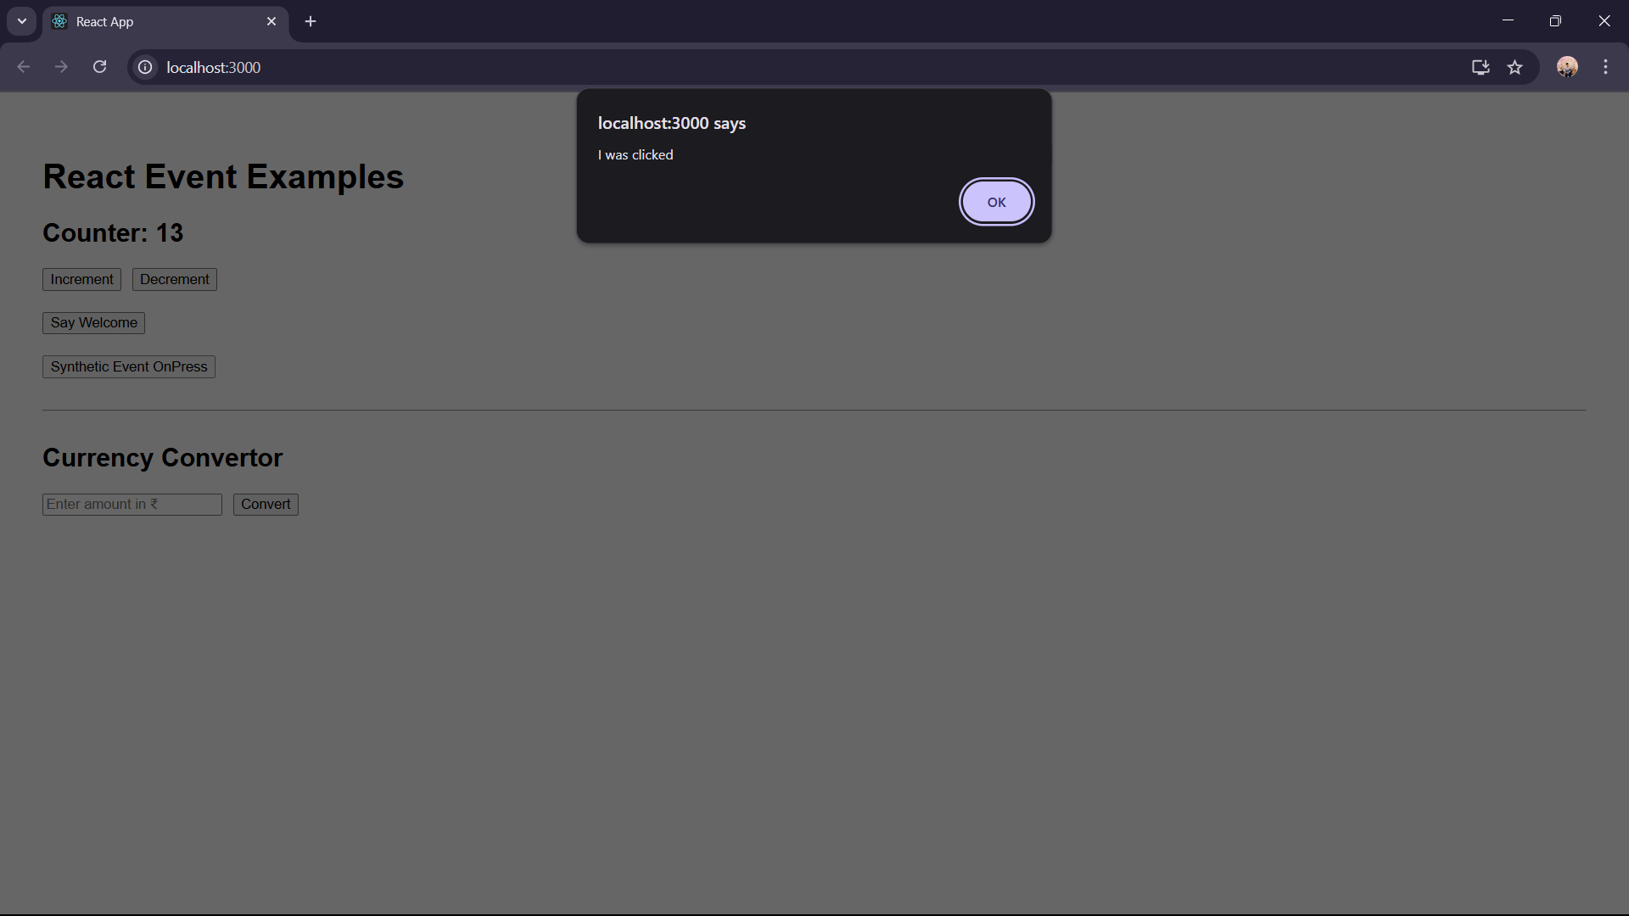
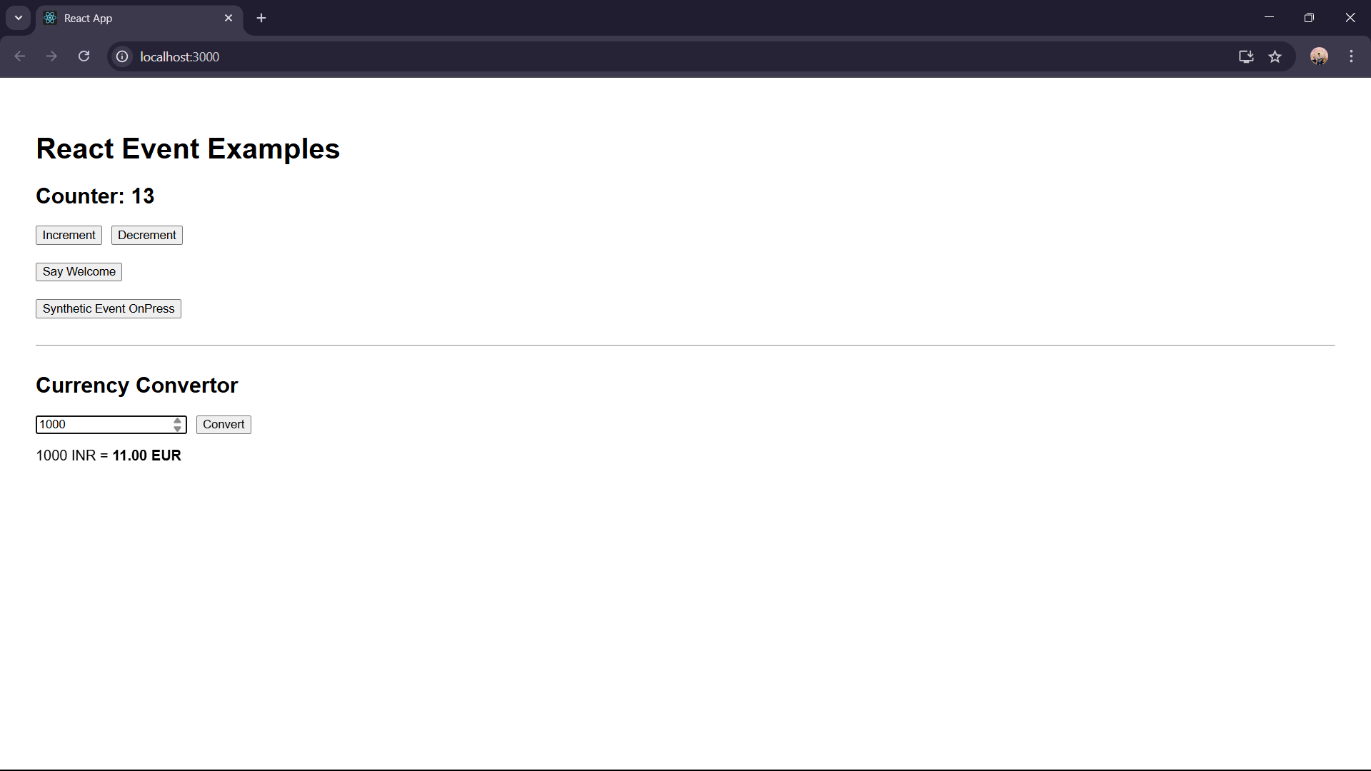

Ex 12
App.js
import React, { useState } from 'react';
import GuestPage from './GuestPage';
import UserPage from './UserPage';

const App = () => {
const [isLoggedIn, setIsLoggedIn] = useState(false);

const handleLogin = () => {
setIsLoggedIn(true);
};

const handleLogout = () => {
setIsLoggedIn(false);
};

let pageContent;

if (isLoggedIn) {
pageContent = <UserPage onLogout={handleLogout} />;
} else {
pageContent = <GuestPage onLogin={handleLogin} />;
}

return (
<div style={{ fontFamily: "Arial", padding: "30px" }}>
<h1>Welcome to Ticket Booking App</h1>
{pageContent}
</div>
);
};

export default App;
GuestPage.js
import React from 'react';

const GuestPage = ({ onLogin }) => {
return (
<div>
<h2>Flight Details (Guest View)</h2>
<ul>
<li>Flight: AI101 | Chennai → Delhi | Time: 10:00 AM</li>
<li>Flight: SG303 | Bangalore → Mumbai | Time: 3:30 PM</li>
</ul>
<button onClick={onLogin}>Login to Book Tickets</button>
</div>
);
};

export default GuestPage;
UserPage.js
import React from 'react';

const UserPage = ({ onLogout }) => {
return (
<div>
<h2>Book Your Ticket</h2>
<form>
<label>
Flight Number:
<input type="text" placeholder="Enter flight number" />
</label>
<br /><br />
<label>
Passenger Name:
<input type="text" placeholder="Enter name" />
</label>
<br /><br />
<button type="submit">Book Ticket</button>
</form>
<br />
<button onClick={onLogout}>Logout</button>
</div>
);
};

export default UserPage;
Output :
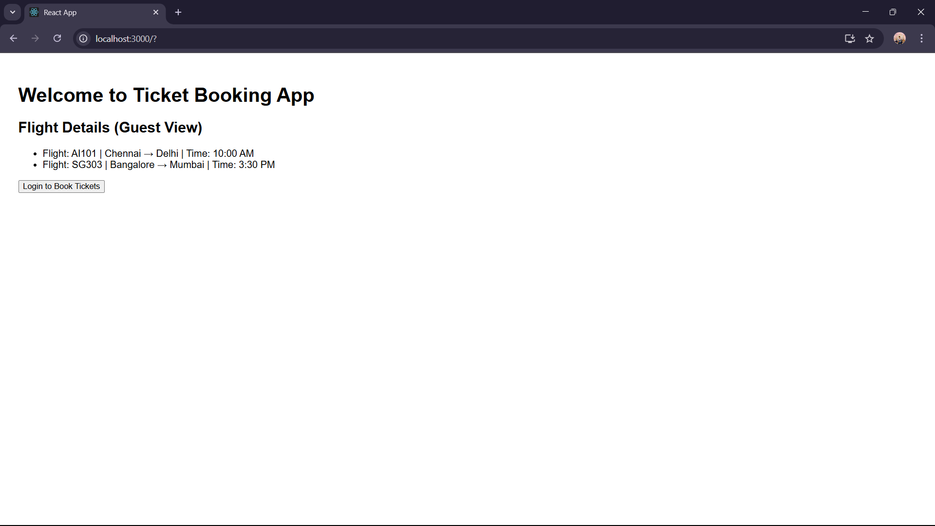
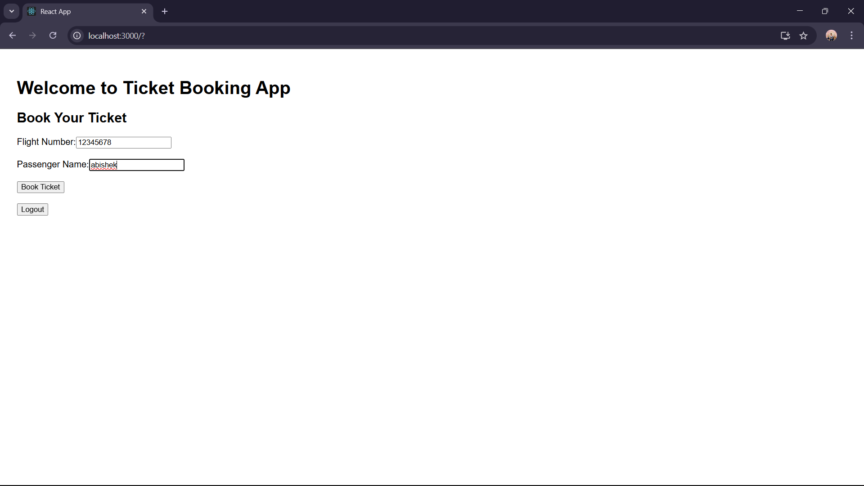

Ex 13
App.js
import React, { useState } from 'react';
import BookDetails from './BookDetails';
import BlogDetails from './BlogDetails';
import CourseDetails from './CourseDetails';

const App = () => {
const [activeComponent, setActiveComponent] = useState("book");

const renderComponent = () => {
if (activeComponent === "book") {
return <BookDetails />;
} else if (activeComponent === "blog") {
return <BlogDetails />;
} else if (activeComponent === "course") {
return <CourseDetails />;
} else {
return <h3>Select an option</h3>;
}
};

return (
<div style={{ padding: "30px", fontFamily: "Arial" }}>
<h1>📘 Blogger App</h1>

<button onClick={() => setActiveComponent("book")}>Show Books</button>
<button onClick={() => setActiveComponent("blog")}>Show Blogs</button>
<button onClick={() => setActiveComponent("course")}>Show Courses</button>

<hr />

{renderComponent()}
</div>
);
};

export default App;
BookDetails.js
import React from 'react';

const books = [
{ id: 1, title: "You Can Win", author: "Shiv Khera" },
{ id: 2, title: "Atomic Habits", author: "James Clear" },
{ id: 3, title: "The Alchemist", author: "Paulo Coelho" }
];

const BookDetails = () => {
return (
<div>
<h2>Book List</h2>
{books.length > 0 ? (
books.map(book => (
<div key={book.id} style={{ marginBottom: '10px' }}>
<strong>{book.title}</strong> by {book.author}
</div>
))
) : (
<p>No books available</p>
)}
</div>
);
};

export default BookDetails;
BlogDetails.js
import React from 'react';

const blogs = [
{ id: 1, title: "React 18 Features", writer: "Anushka" },
{ id: 2, title: "Frontend vs Backend", writer: "Abishek" }
];

const BlogDetails = () => {
return (
<div>
<h2>Blog List</h2>
{blogs.length === 0 && <p>No blogs to show</p>}
{blogs.length > 0 && (
<ul>
{blogs.map((blog) => (
<li key={blog.id}>
{blog.title} - <i>{blog.writer}</i>
</li>
))}
</ul>
)}
</div>
);
};

export default BlogDetails;

CourseDetails.js
import React from 'react';

const isLoggedIn = true;
const enrolledCourses = ["React", "Node.js", "MongoDB"];

const CourseDetails = () => {
return (
<div>
<h2>Courses</h2>
{isLoggedIn ? (
<div>
<p>Welcome! You are enrolled in:</p>
<ul>
{enrolledCourses.map((course, idx) => (
<li key={idx}>{course}</li>
))}
</ul>
</div>
) : (
<p>Please login to view courses</p>
)}
</div>
);
};

export default CourseDetails;

Output :
